Sales Analysis Using Power BI

1. Project Title:
Superstore Sales Analysis Using Power BI

2. Introduction:

Description:
Sales analytics is the process of analyzing sales data to understand business performance, identify trends, and support decision-making.
In this project, the Superstore sales dataset is analyzed using Power BI to gain insights into sales, profit, customers, products, and regions.

Purpose:
The purpose of this project is to:
- Analyze overall sales and profit performance
- Identify top-performing products and regions
- Understand customer purchasing behavior
- Detect loss-making products and regions
- Build interactive dashboards for business users

3. Business Problem Statement
The company wants to understand:
- Which products generate the highest sales?
- Which regions contribute the most revenue?
- Which customers are most valuable?
- Which products and regions cause losses?
- How sales performance changes over time?

4. Objectives of the Project

Main Objectives:
- Calculate key sales metrics such as total sales, profit, and quantity
- Analyze sales by product, category, region, and customer
- Identify top and low-performing products
- Design interactive dashboards using Power BI
- Provide actionable business insights and recommendations

5.Tools & Technologies Used:
Tool | Purpose
Power BI | Data visualization & dashboard
Power query | Data cleaning & transformation
DAX | KPI calculations
CSV | Dataset

6. Dataset Description:

Source -SuperStore_Sales_Dataset.csv

7.Data Preprocessing Steps

7.1 Data Loading:
- Imported dataset into Power BI using CSV file.
- Home → Get Data → CSV file → Load
Dataset Preview Before Loading:
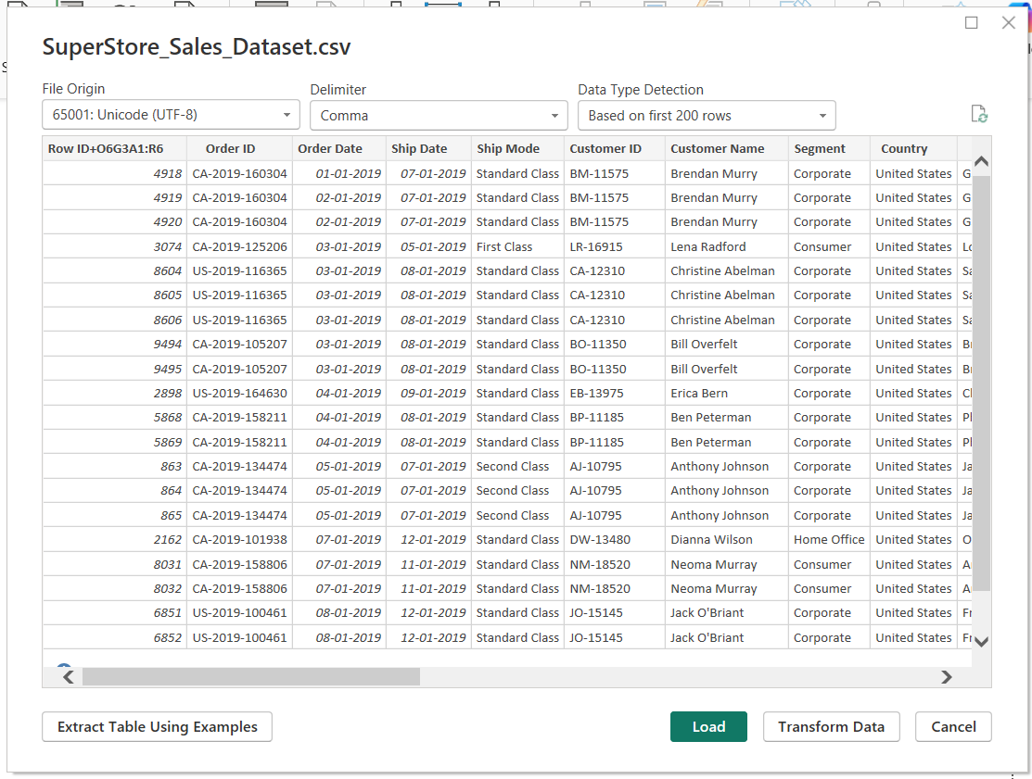

Before Data cleaning:
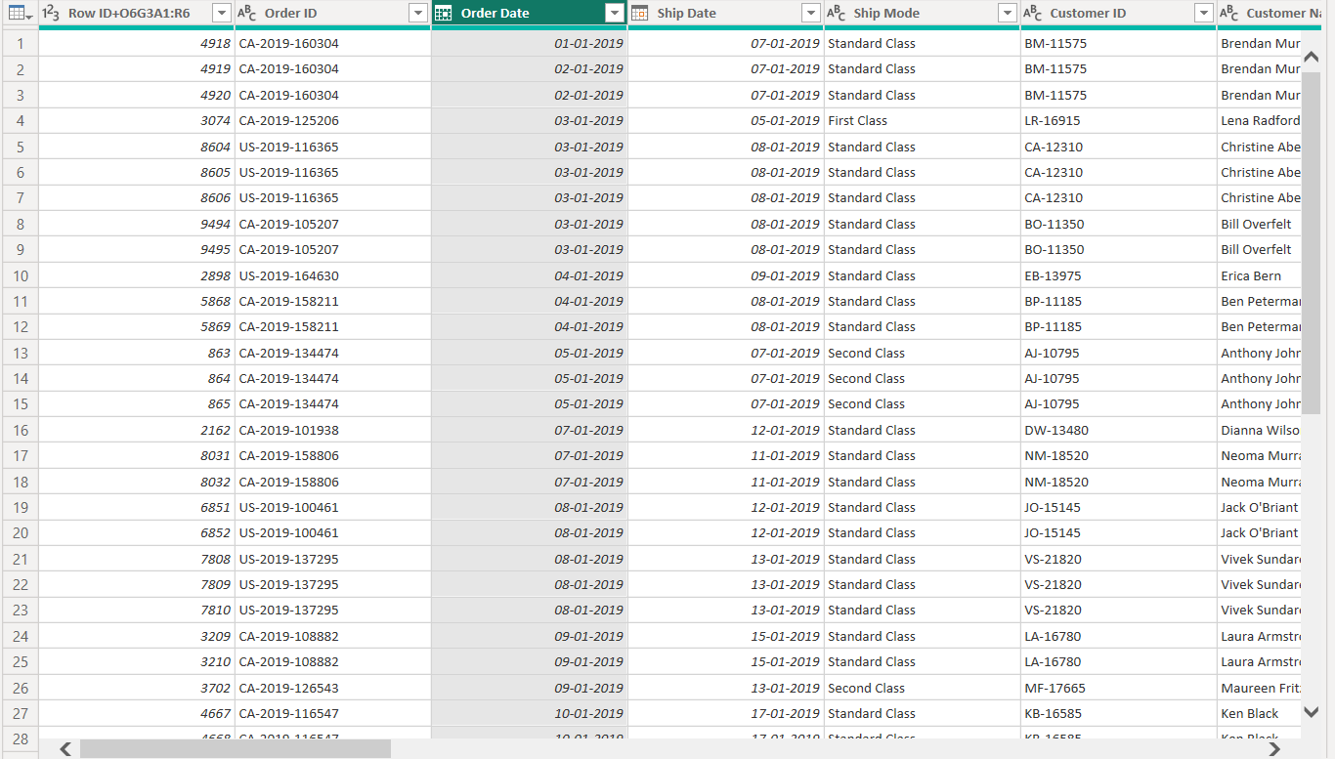
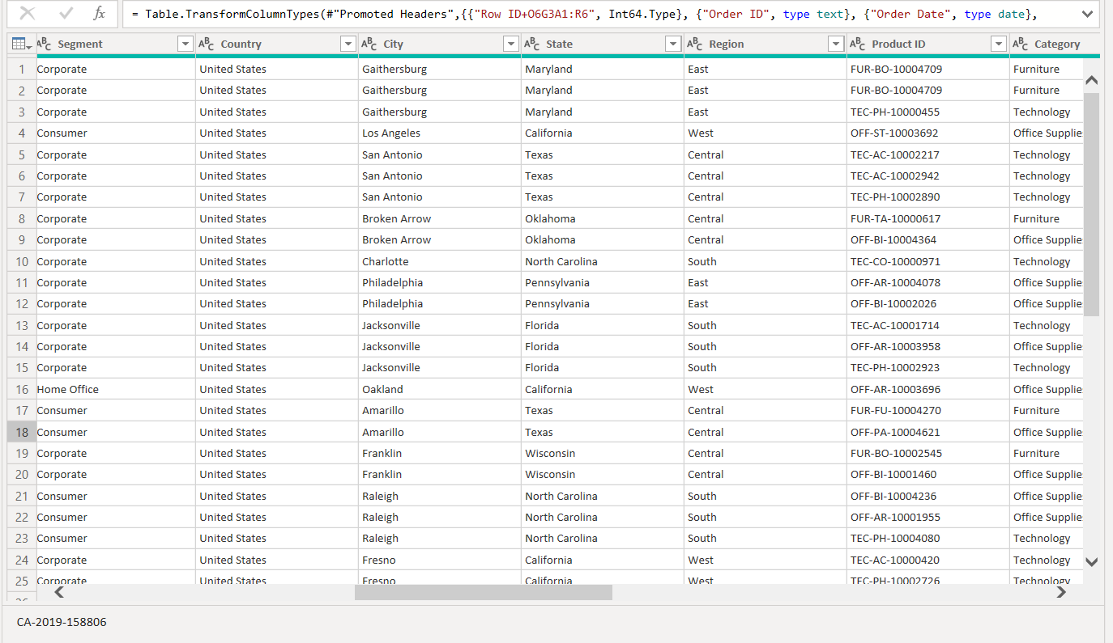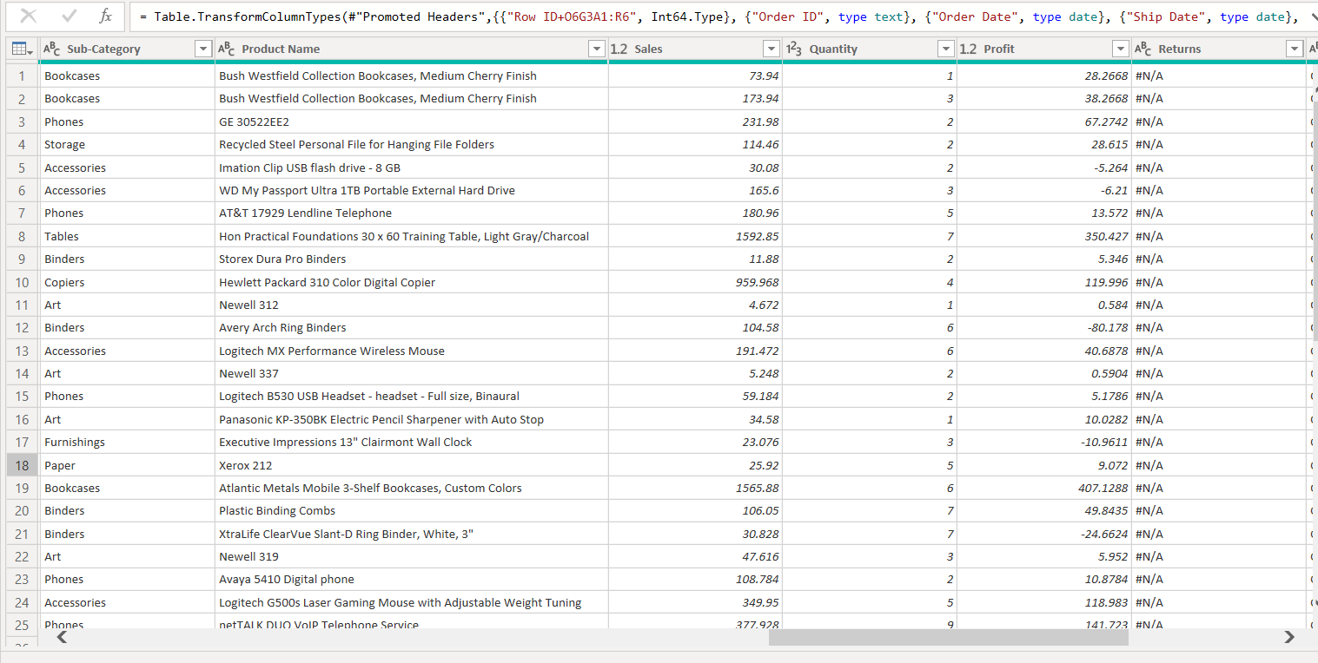
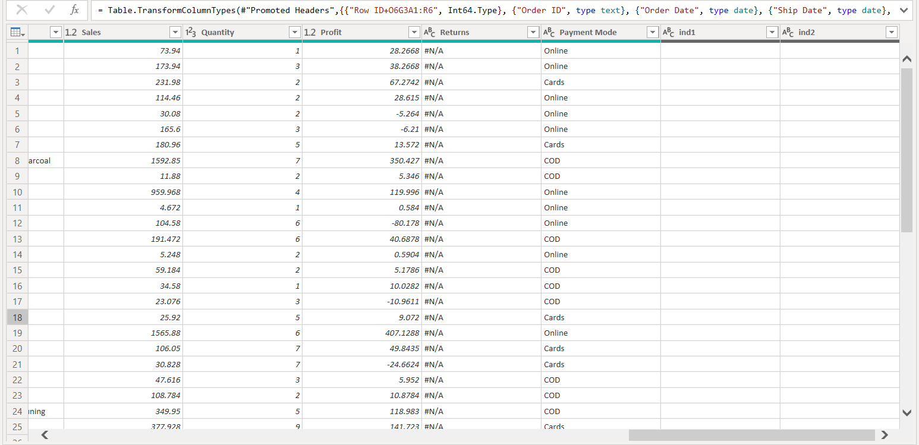

7.2: Data Cleaning and Transformation:

Step 1: Open Power Query Editor
Power BI → Home → Transform Data

7.2.1 Data Type Standardization
The data types of all columns were standardized using Power Query Editor.
Key columns such as Order Date, Ship Date, Sales, Profit, and Quantity were converted into appropriate data types to ensure accurate calculations and reliable analysis.
7.2.2Remove Duplicates
Check duplicates in Order ID
Power Query:
- Select column → Order ID
- In dataset there was 5901 records
- Home → Remove Rows → Remove Duplicates
- Now 3003 records

7.2.3 Remove unnecessary columns:
- Select columns → ind1, ind2
- Right click → Remove Columns

7.2.4 Create Return Flag Column (Conditional Column)
IF Returns = #N/A , then No

7.2.5 Trim, Clean & Standardize Text Columns:
- Text-based columns such as Customer Name, Product Name, Category, Sub-Category, Region, State, City, and Payment Mode were cleaned using Power Query.
- Extra spaces and hidden characters were removed using Trim and Clean functions, and text values were standardized using proper formatting to ensure consistency across categorical fields.
7.2.6 Create Derived Columns:
Column Name: Profit_Status
Condition:
- If Profit > 0 → "Profit"
- Else → "Loss"
Column Name: Sales_Category
Logic:
- If Sales < 1000 → "Low Sales"
- Else if Sales < 5000 → "Medium Sales"
- Else → "High Sales"

7.2.6 Creation of Fact and Dimension Tables:

Main Table as Fact_Sales:

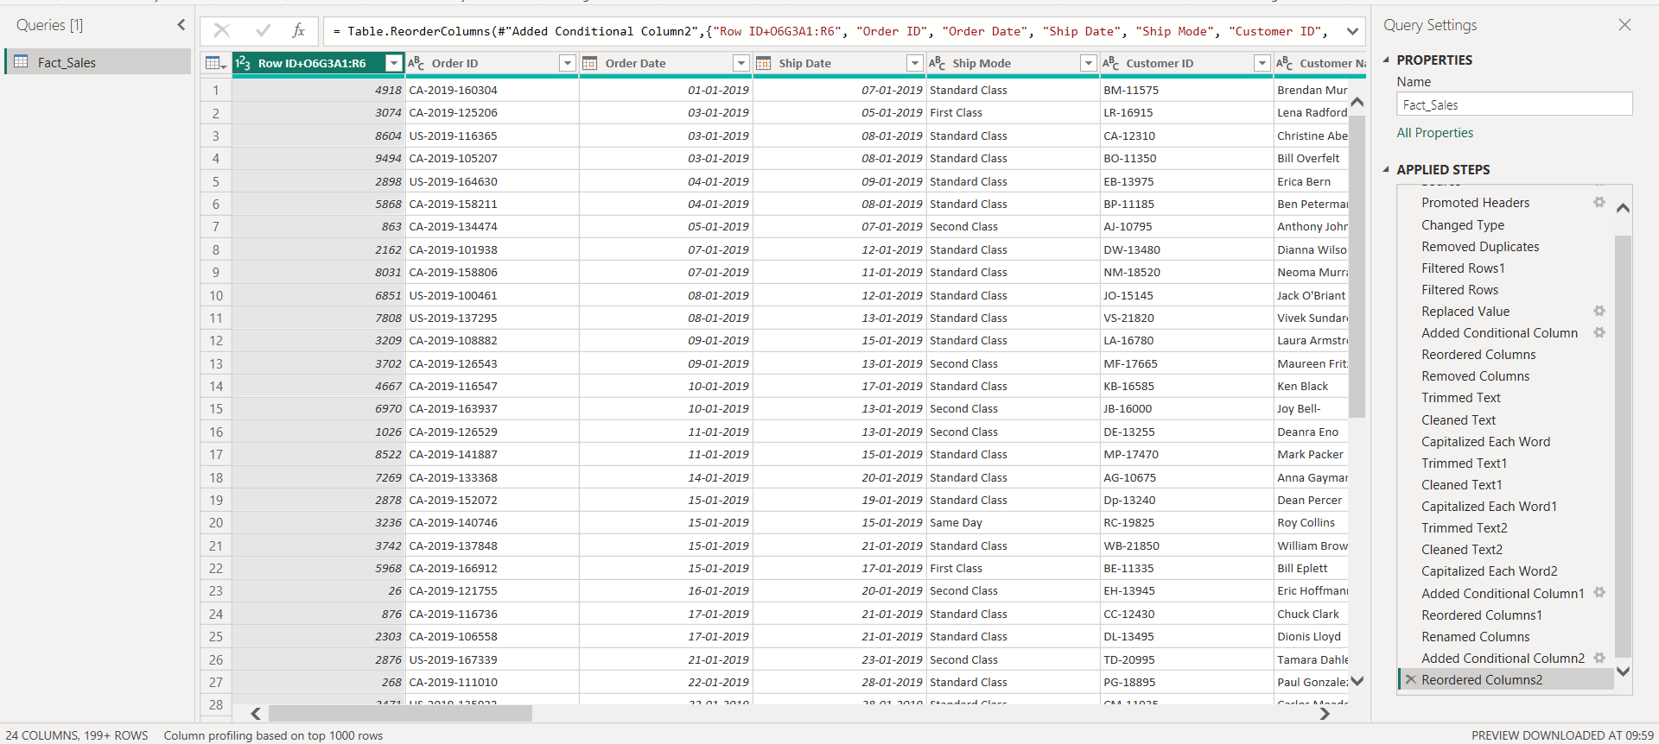

Create Dim_Customer Table
What is Dim_Customer?
We want only customer details from Fact_Sales.
We will extract:
- Customer ID
- Customer Name
- Segment

Create Reference Table
In Power Query,Right click on Fact_Sales (left side)
Click Reference
New table will appear.
Keep Only Customer Columns
Now in new table:
Keep ONLY these columns
- Customer ID
- Customer Name
- Segment
How to remove other columns?
- Select these 3 columns (Ctrl + click)
Right click → Remove Other Columns
- Now only 3 columns remain.
Remove Duplicates
- Select Customer ID column
Home → Remove Rows → Remove Duplicates
Rename Table
- Right click table name
Rename → Dim_Customer

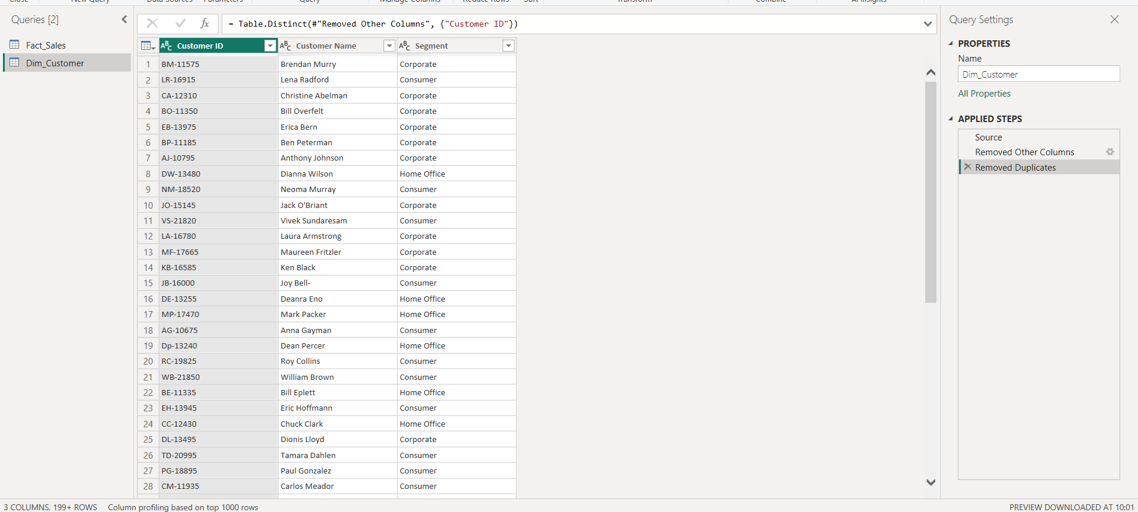

Create Dim_Product Table
Create Reference Table
Right click Fact_Sales
Click Reference
Keep Only Product Columns
Keep ONLY these columns:
- Product ID
- Product Name
- Category
- Sub-Category
Select these 4 columns (Ctrl + click)
Right click → Remove Other Columns
Remove Duplicates
Select Product ID column
Home → Remove Rows → Remove Duplicates
Rename Table – Dim_product
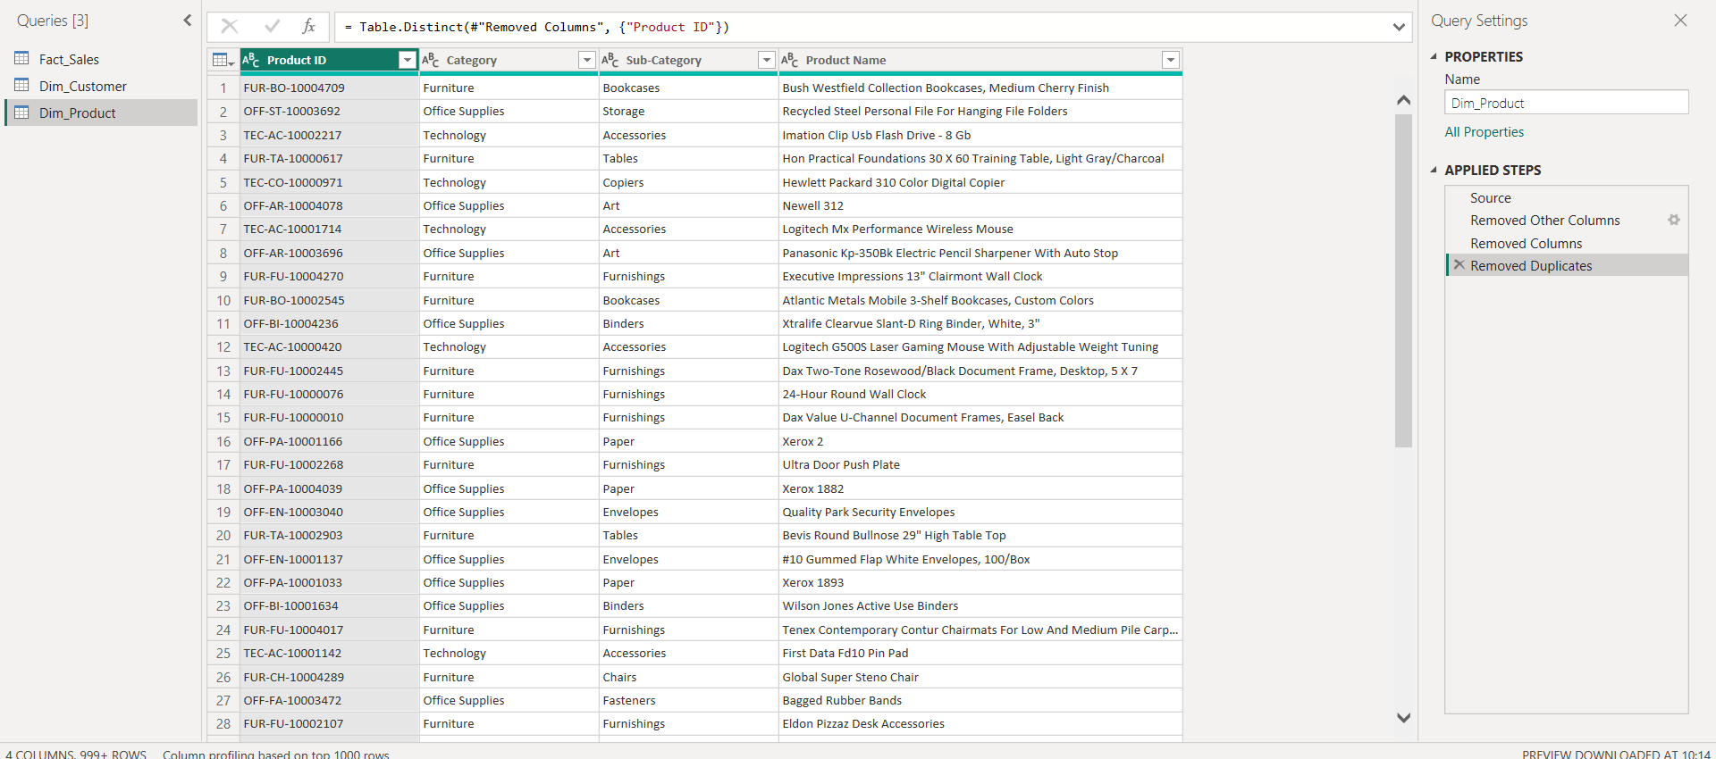

Create Dim_Region Table
Create Reference Table
Right click Fact_Sales
Click Reference
Keep Only Product Columns
Keep ONLY these columns:
- Country
- Region
- State
- City
Select these 4 columns (Ctrl + click)
Right click → Remove Other Columns
Remove Duplicates
Select all columns (Ctrl + A)
Home → Remove Rows → Remove Duplicates
Rename Table – Dim_Region

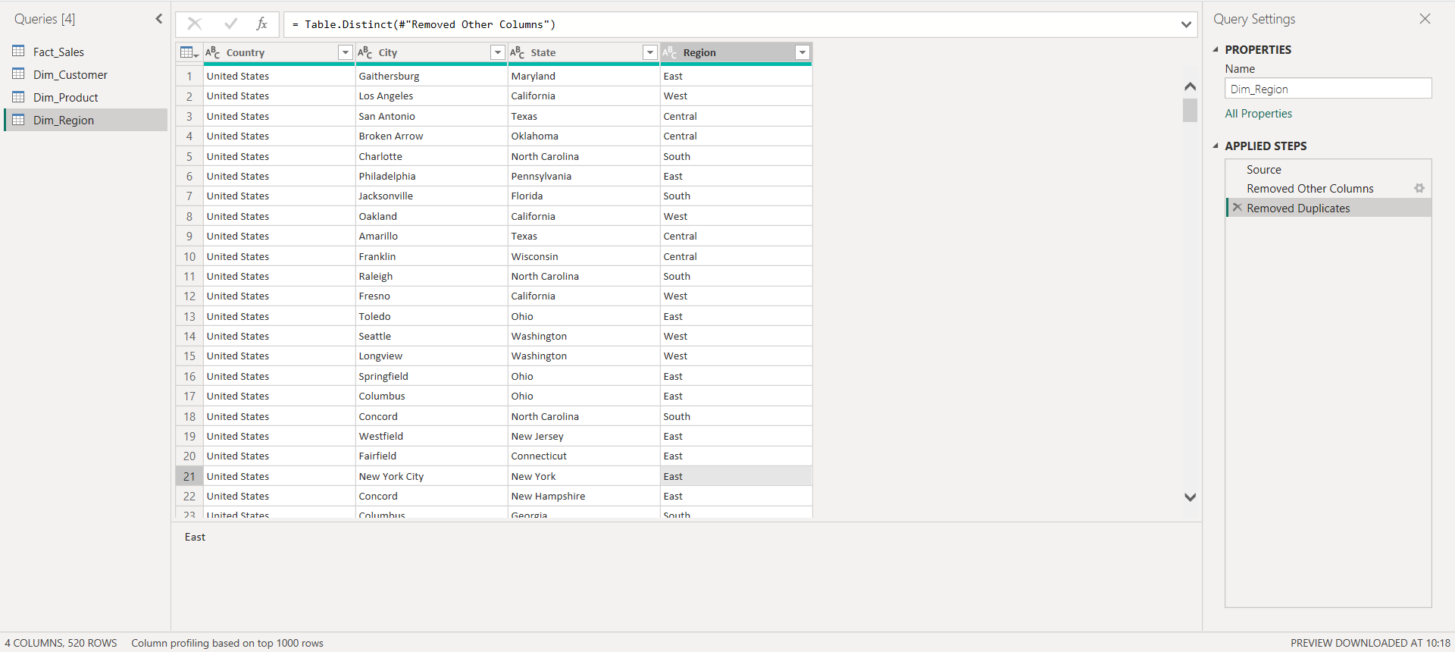

Create Dim_Date Table (Required for YoY Growth

Why we need Dim_Date?
Fact_Sales has Order Date, but:
- Power BI time intelligence (YoY, MoM) needs a proper Date table

Create New Table (DAX)
Modeling → New Table
Dim_Date =
ADDCOLUMNS(
CALENDAR (DATE(2018,1,1), DATE(2025,12,31)),
"Year", YEAR([Date]),
"Month Number", MONTH([Date]),
"Month Name", FORMAT([Date], "MMM"),
"Quarter", "Q" & FORMAT([Date], "Q"),
"Year-Month", FORMAT([Date], "YYYY-MM")
)
Create Relationship:
Fact_Sales[Order Date] → Dim_Date[Date]

7.3 Data Modeling:
1.Create STAR SCHEMA
2.Go to Model View
In Power BI Desktop:Click Model View icon
- Fact_Sales
- Dim_Customer
- Dim_Product
- Dim_Region
- Dim_Date
3.Create Relationships:
- Customer Relationship: Fact_Sales[Customer ID] → Dim_Customer[Customer ID]
- Product Relationship: Fact_Sales[Product ID] → Dim_Product [Product ID]
- Region Relationship: Fact_Sales[city ] → Dim_Region [city]
- Date Relationship:Fact_Sales[Order Date] → Dim_Date[Date]
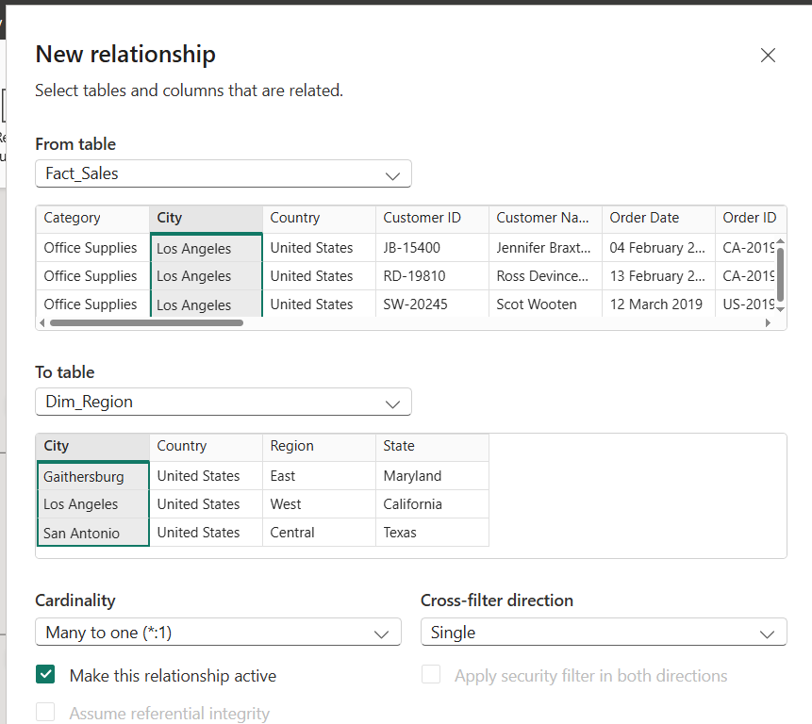
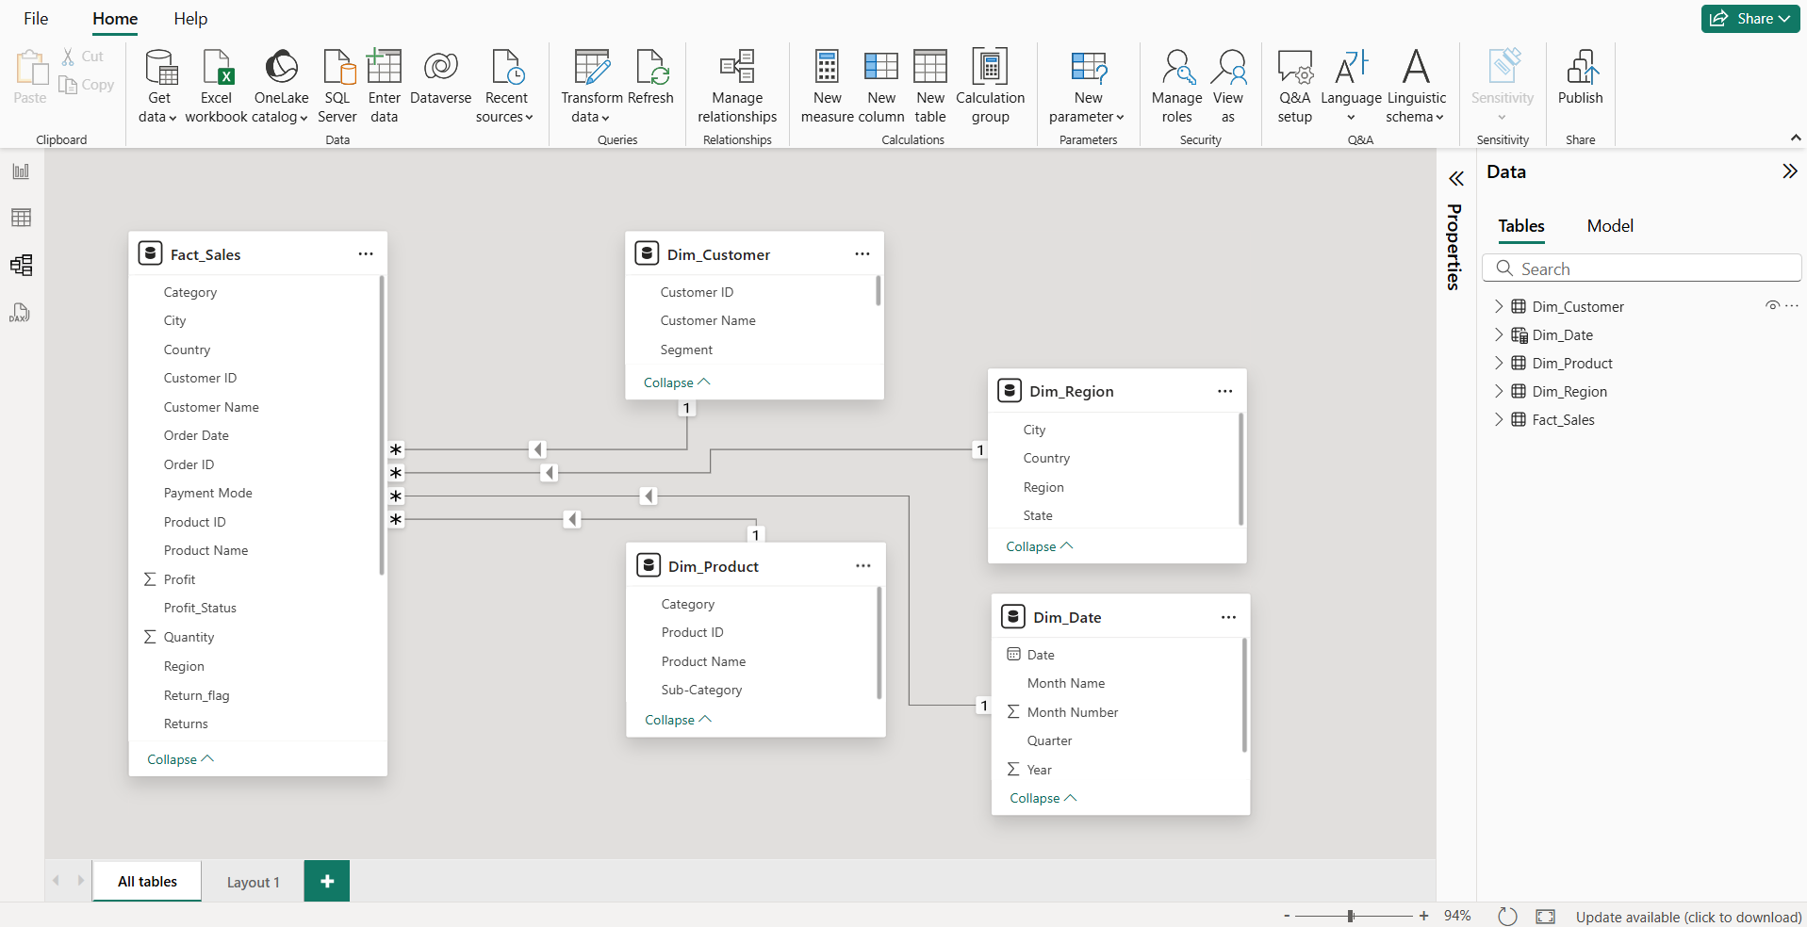
Dim_Customer
|
Dim_Product ---- Fact_Sales ---- Dim_Region
|
Dim_Date
The dataset was modeled using a star schema design, where the Fact_Sales table acts as the central fact table and is connected to multiple dimension tables such as Dim_Customer, Dim_Product, and Dim_Region.
Many-to-one relationships were created between the fact and dimension tables to ensure efficient filtering and optimized query performance.

7.4 DAX MEASURES:
Power BI → Modeling → New Measure
7.4.1 Create Total Sales Measure:
Total Sales: Calculates overall revenue generated.
Total Sales = SUM(Fact_Sales[Sales])
7.4.2 Total Profit: Measures total profit from sales.
Total Profit = SUM(Fact_Sales[Profit])
7.4.3 Total Quantity: Represents total units sold.
Total Quantity = SUM(Fact_Sales[Quantity])
7.4.4 Total Orders: Counts unique customer orders.
Total Orders = DISTINCTCOUNT(Fact_Sales[Order ID])
Advanced DAX Measures:
Additional business metrics were created using DAX to derive deeper insights into sales performance, including Profit Margin percentage and Average Order Value.
7.4.5 Profit Margin %
Profit Margin % =How much profit you make from total sales
Profit Margin % = DIVIDE([Total Profit], [Total Sales], 0)
Numerator = Total Profit
Denominator = Total Sales
Alternate result = 0 (if denominator = 0)

7.4.6 Average Order Value (AOV)
Avg Order Value (AOV) = DIVIDE([Total Sales],[Total Profit],0)
7.4.7 Sales YoY Growth (Year-over-Year)
- A Year-over-Year (YoY) growth measure was created using DAX to compare current year sales with the previous year.
- The SAMEPERIODLASTYEAR function was used to calculate last year’s sales, and YoY growth percentage was derived to analyze sales performance trends over time.
We will create 2 measures:
- Sales Last Year
- YoY Growth %
1.Sales Last Year:
Sales Last Year =
CALCULATE(
[Total Sales],
SAMEPERIODLASTYEAR(Dim_Date[Date])
)
Alternate query used:
Sales Last Year =
CALCULATE(
[Total Sales],
Dim_Date[Year] = MAX(Dim_Date[Year]) - 1
)

2.Sales YoY Growth %
Sales YoY Growth % =
DIVIDE(
[Total Sales] - [Sales Last Year],
[Sales Last Year]
)

8.DASHBOARD DESIGN AND PUBLISHING IN POWER BI SERVICE:

KPI Cards
- Total Sales
- Total Profit
- Total Quantity
- Total Orders
- Profit Margin %

Visuals Included
- Quarter-wise Sales
- Region-wise Sales
- Category-wise Sales
- Product-wise Sales
- Monthly Trend Analysis
- Profit Margin by Segment
- YoY Growth by Year

Filters
- Year
- Region
- State
- Sub-Category
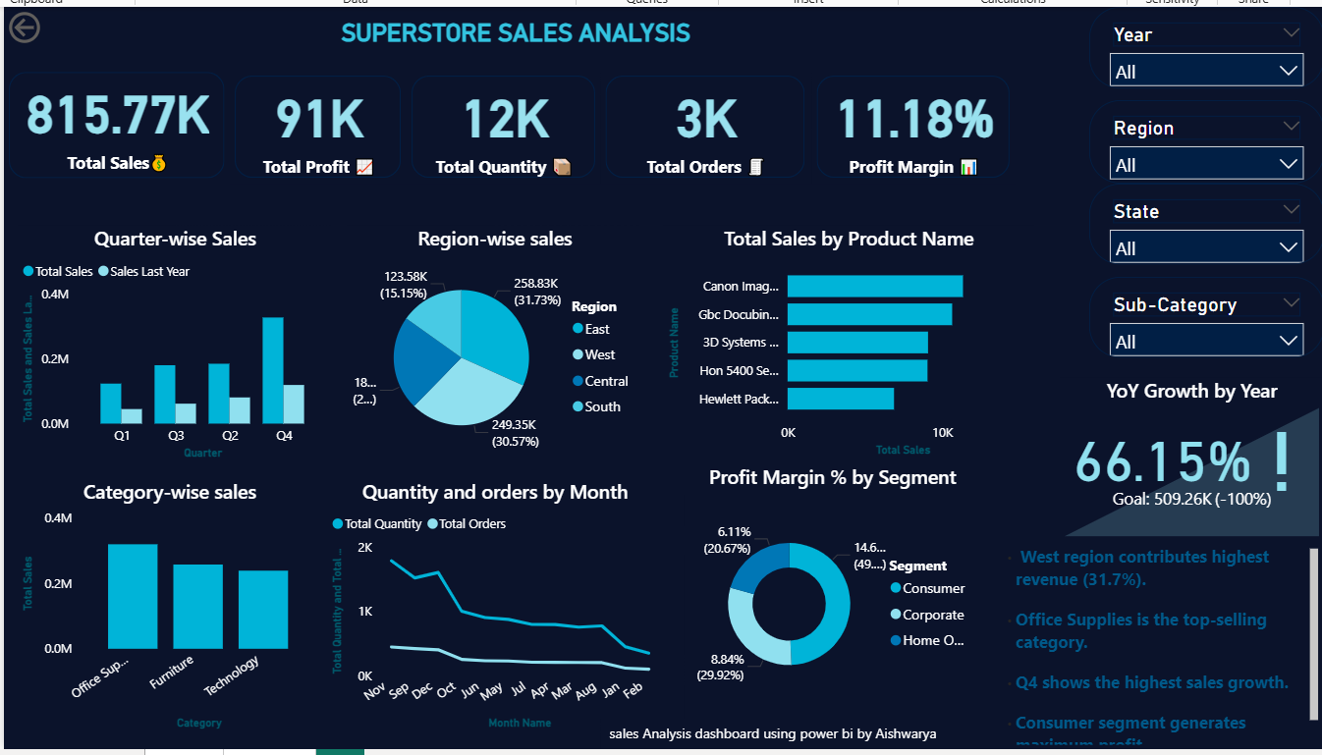

9. Insights and Findings
- West region contributes the highest revenue (~31.7%)
- Office Supplies is the top-selling category
- Q4 shows the highest sales growth
- Consumer segment generates maximum profit
- Sales show strong YoY growth

10. Business Recommendations
- Focus marketing on high-performing regions
- Optimize low-performing product categories
- Improve supply chain for high-demand products
- Retain high-value customers
- Reduce loss-making products

11. Conclusion
This project demonstrates end-to-end data analytics using Power BI, including data modeling, DAX calculations, and interactive dashboard development. The dashboard enables business stakeholders to make data-driven decisions using real-time insights.
Project By: Aishwarya

